PMS enhancement suggestion

Induction Training :-

- Induction training TAB - additional drop down required for Not required/Not applicable , Others & Extra column for remarks.
- Date of training - should only accept the date as per the prescribed format, if data is not as per prescribed format then it s’ld not accept.
Ideally date should be entered as 02-Jan-15 instead of 02/01/ 2015, Coz if we change format then date may also change to 1st Feb’2015.
- When we generate New joinee MIS we should also get Induction status .

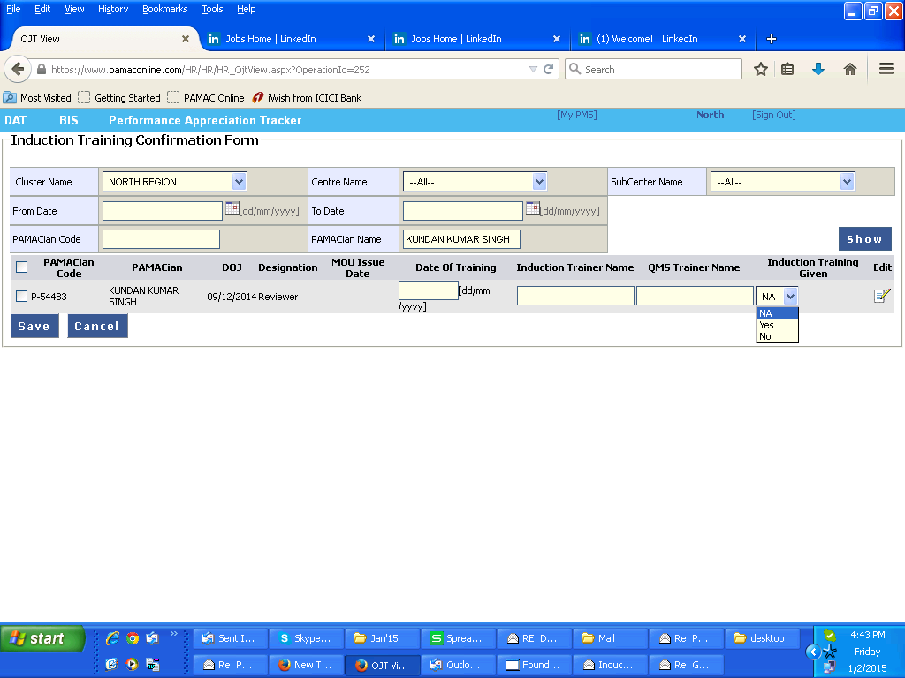

BIS entry:-

- BIS should accept single name, instead of we adding any incorrect details like fathers name or last name. This leads to incorrect data while issuing cheques
- If Last name is must then we s’ld add some dummy like NA.
- During BIS punching we s’ld have additional TAB - Inhouse/ client premises/ contractual.
- During BIS punching we s’ld have additional TAB -PMT mapping/reporting name( so that the person authorised for updating PMT will be alloted directly)
We don’t have to add persons name separately in PMT, it will happen automatically & chances of pending PMT will be lesser or zero.

